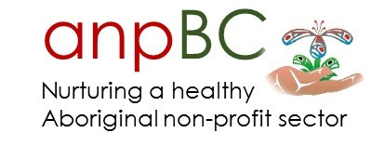

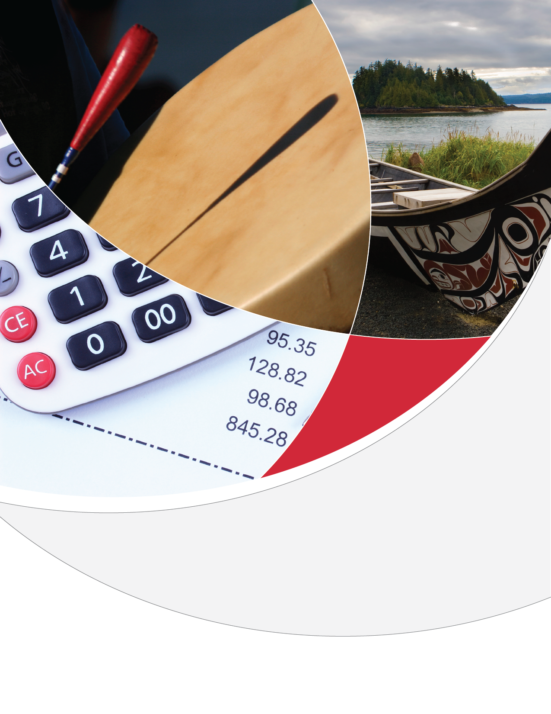
Honouring the Seasons of Your life
Planning Holistically for your Retirement and Journey as an Elder
Participant Workbook
(Draft) Jan 27, 2017
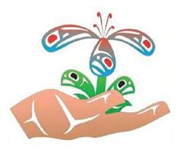

Copyright © All Rights Reserved
BC Association of Aboriginal Friendship Centres
Developed by Arrive Consulting and Roundtable Consulting Inc.

About the anpBC Strategy
The Aboriginal Non-profit Workforce and HR Strategy is an effort to strengthen the Aboriginal non-profit sector by developing human resources and workforce strategies. The sector includes agencies and organizations that deliver services in the areas of health, employment, child and family services, treatment, and housing.

About the Logo
“This print represents the perseverance and sustenance involved when we work for our communities. The salmon represents perseverance and is about respect for tradition, intuition, inner voice, determination, and ability to follow your vision. The hummingbird represents sustenance and is the great nectar of Life, great beauty, love and harmony, the tireless song of joy.” –Artist Jamin Zuroski, ‘Namgis First Nation
Contents
Introduction 3
Holistic Retirement Planning – Circle Graphic 4
Compound Interest 5
Benefits of Starting Early – Lily and Kelsie 6
Pathways to Retirement 7
Pathways to Retirement Key Terms 8
Calculating your Elder Years Income 10
Holistic Retirement Planning – Action Plan Sheet 11
Taking the Next Steps – Ideas and Resources 12

Introduction

Indigenous cultures have always placed a high value on planning ahead, supporting Elders and living holistically. This Honouring the Seasons of your Life curriculum explores how these Indigenous values relate to transitioning to Elderhood and supporting Elders in today’s world.

Whether you’re a young person getting started in your career, someone who is mid-career, or someone for whom Elderhood is just around the corner, this curriculum is for you. It is never too early, or too late, to start thinking about the next phase of your life.

In developing this curriculum, we heard from many people that “retirement” is not an Indigenous concept, and that in fact many Indigenous people don’t really “retire.” Even when they are no longer fully employed, they often keep volunteering and doing part-time work that contributes to the well-being of their communities and families. We also heard that Indigenous values around savings and wealth differ from non-Indigenous values, and need to be honoured in any approach to financial planning.

Thus, this curriculum explores the transition to Elderhood within the context of Indigenous culture, looking not just at “retirement,” but at the role and value of an Elder, and how communities can support Elders. It addresses how communities prior to colonization planned for the future, as well as how colonization impacted those practices and values. It also looks at how people are keeping Indigenous practices and values around community and caring for Elders alive today, and how individuals and organizations can better support Elders.

Our hope is that this curriculum will help you to envision and plan for your future holistically and in a way that aligns with your cultural values, in order to achieve the quality of life you desire when you get older.

About this workbook
This workbook contains the main visuals and tools used for delivery of the curriculum as part of group workshops. It also contains links to some key resources. To view the full curriculum including videos please visit the anpBC Holistic Retirement and Living as an Elder main webpage at:
http://anpbc.com/toolkits/holistic-retirement-planning/

Links to core curriculum videos:
- Traditional Indigenous Concepts of Economy and Elderhood (Module 1): https://youtu.be/cBAuOdigtgg

- The Importance of Planning for Retirement (Module 2): https://youtu.be/qWvyAXhHlQs

- Living Well as an Elder and Supporting Elders (Module 5): https://youtu.be/5TP8QiJ2U1Q

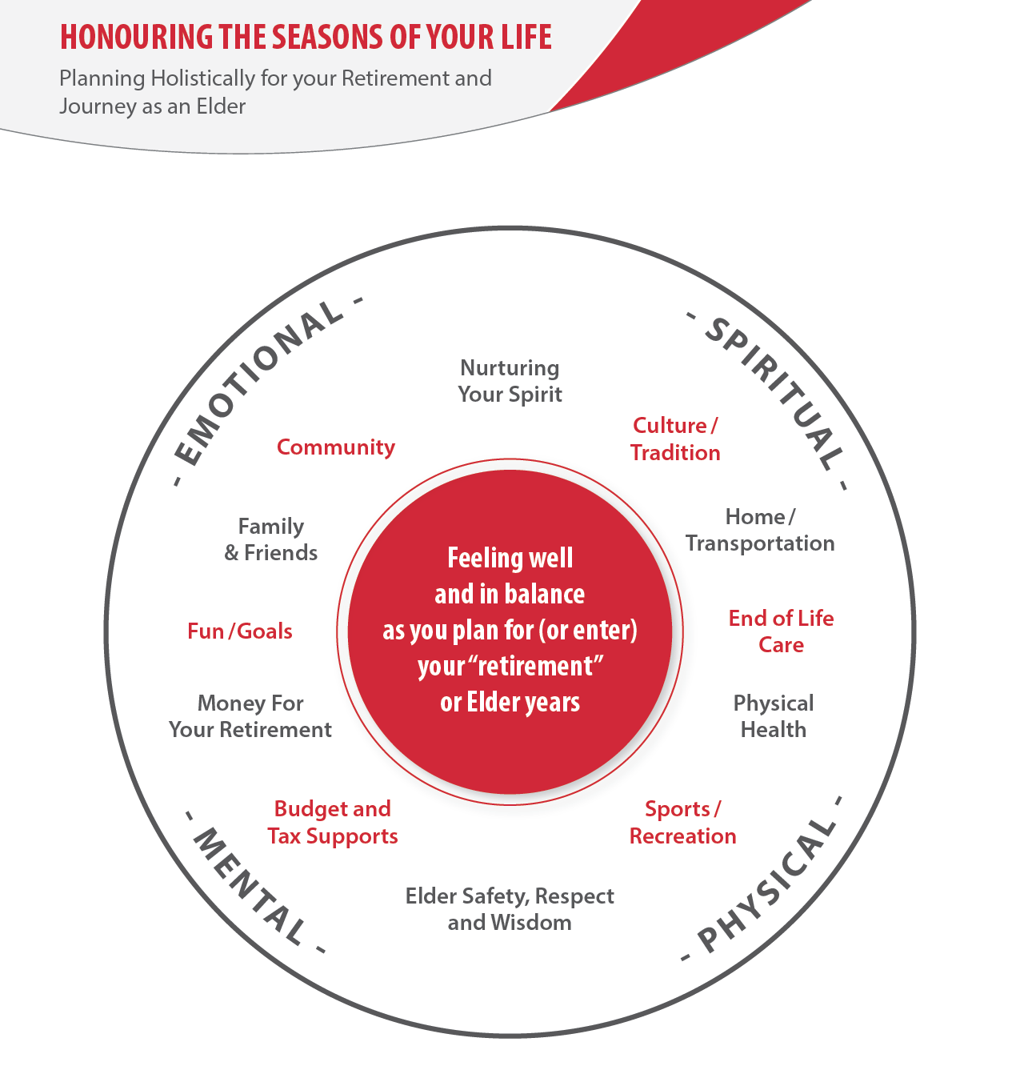
Holistic Retirement Planning – Circle Graphic

Compound Interest
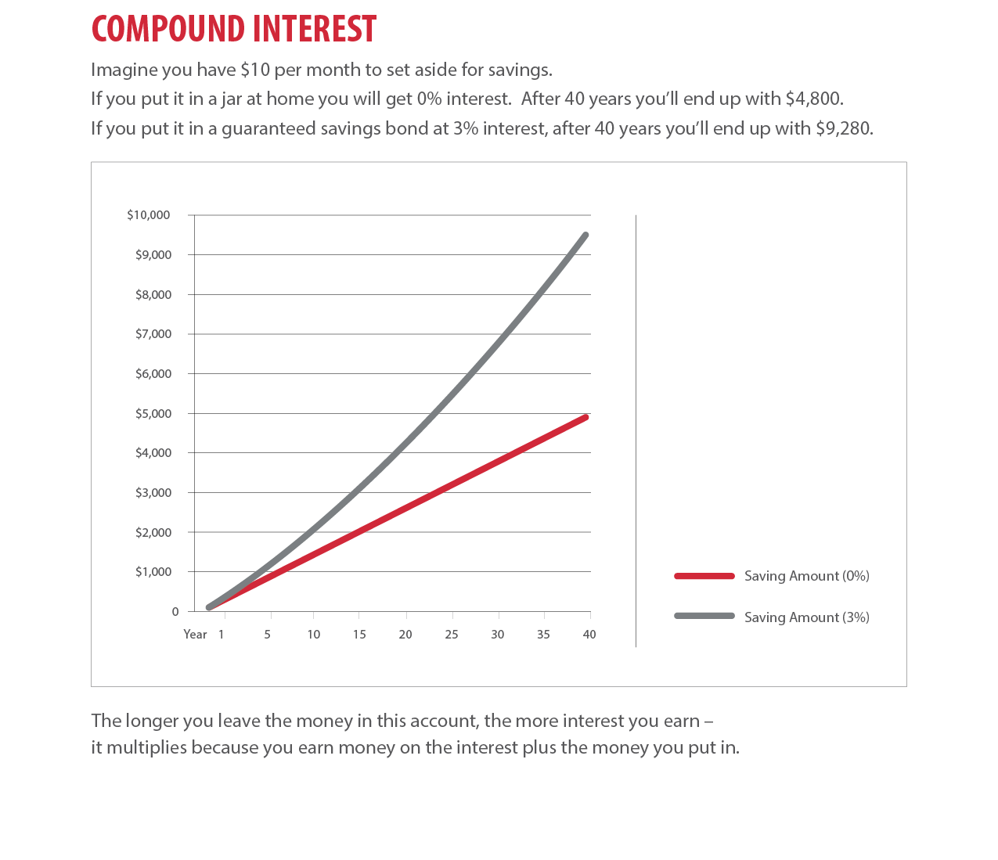

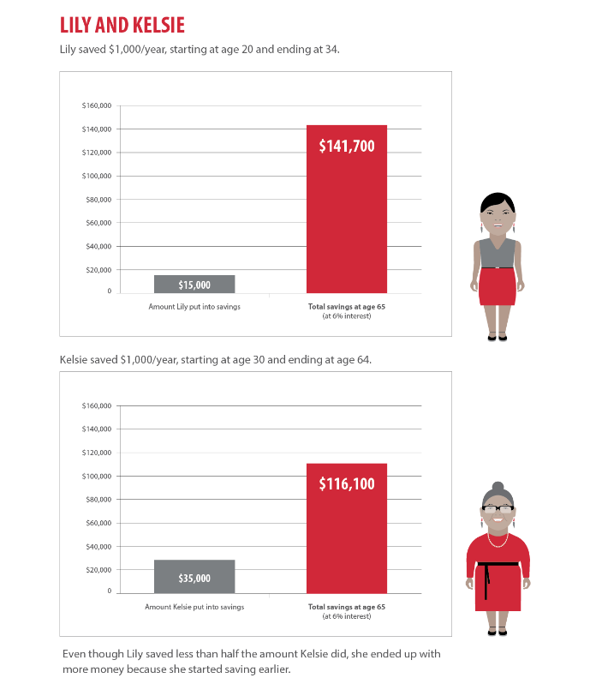
Benefits of Starting Early – Lily and Kelsie

Pathways to Retirement
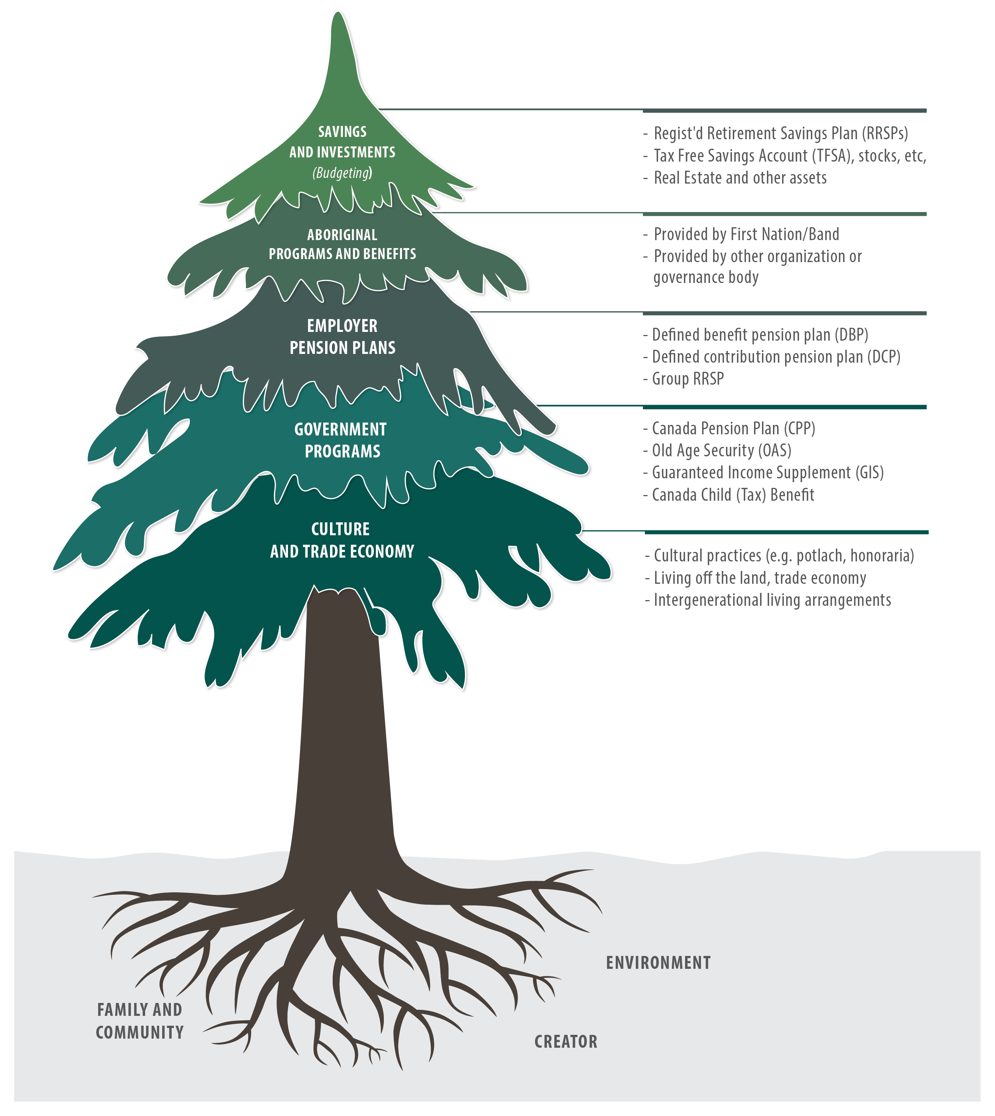
7

Pathways to Retirement Key Terms

Culture and Trade Economy
Elder honoraria: In Indigenous communities an Honorarium is as gift of appreciation to Indigenous Elders or knowledge keepers for sharing their traditional knowledge or gifts in a show of reciprocity. While historically Elders were given food or other essentials for their help, today money is often used.
Culture and trade economy: Economic activity which include subsistence practices (e.g. hunting, fishing and harvesting), trade and barter, and cultural or ceremonial activities, where goods, services, wisdom, power and gratitude are exchanged and woven into the fabric of everyday life. These exchanges of energy and resources help sustain people and communities and are an essential part of the larger economy of a region or nation.
Intergenerational living arrangement: multi-generational households are those housing three or more generations, typically with grandparents living in the same house as their grandchildren and helping provide care when the parents are at work, at school or running errands, and younger generations helping care for their senior relatives, who benefit from the company of loved ones in a familial setting.

Government Programs
Canadian Pension Plan (CPP): The Canada Pension Plan is a retirement plan operated by the Canadian government. Most employees and employers are required to pay into CPP. However this is not always the case for employees working on reserve—in this case paying into the plan may be optional rather than required. Upon retirement individuals will receive a regular payment from the Canadian government, and the amount of this payment is based on how much they have contributed.

Old Age Security (OAS): The Old Age Security program is a program operated by the Canadian government. Most citizens of Canada are eligible upon retirement, regardless of their employment history.

Guaranteed Income Supplement (GIS): The Guaranteed Income Supplement (GIS) provides a monthly non-taxable benefit to Old Age Security (OAS) pension recipients who have a low yearly income (e.g. less than $17,500 in 2017 for single person). Note retirees should be careful when checking the GIS box when applying for OAS and claiming this benefit if they earn more income than the maximum allowable.

Canada Child Benefit: The Canada Child Benefit (formerly the Canada Child Tax Benefit) is a tax-free monthly payment made to families to help them with the cost of raising children under 18 years of age. Grandparents who are primary caregivers can also receive this payment.
Employer Pensions Plans
There are generally two types of employer pensions plans: Defined Benefit or a Defined Contribution Pension Plan. Sometimes contributions to the plan are optional and sometimes they are required. Usually these contributions come off one’s paycheque (as noted on pay stubs) and both employees and employer make contributions.

Defined benefit pension plan (DBP): A type of pension plan in which employers promise a specified pension payment based on an employee's salary history, length of service and age. Most pension plans of government employees are defined benefit plans.

Defined contribution pension plan (DCP): A type of pension plan in which money is set aside each year by a company for the benefit of its employees (through employer contributions and sometimes employee contributions) and future benefits depend on the money in the account plus any investment earnings.

Group RRSP: A Group RRSP is a collection of individual RRSPs offered to employees by their sponsoring employer. Both employees and employers may contribute depending on the rules of the plan and contributions are taken from pre-tax earnings through payroll deductions.

Personal Savings and Investments
Registered Retirement Savings Plan (RRSPs): A savings plan which reduces an employee’s taxable income in a given year, therefore allowing them to pay less tax. The money put in an RRSP and the interest earned is not taxed until it is withdrawn in the future, ideally in retirement when one’s yearly income is lower.

Tax-Free Savings Account (TFSA): A tax-advantage savings program through which individuals can save money without paying taxes on their investment earnings. Money can be withdrawn anytime tax free, but there are rules concerning how much can be put into the account in a year.

High interest savings account: This is a type of deposit account in which the bank pays interest on the deposits. The interest is slightly higher than a regular savings account. This is a very safe way to save. It is best used for short to medium-term investments.

Bonds: This is a type of investment. It means that investors lend their money to a government or a corporation, who pay interest on the loan over a period of time called a term. When the term is over, investors get all of their money back plus interest. Government bonds in Canada are very safe. Corporate bonds hold some risk. Bonds can be used to save for medium or long-term goals.

Stocks and mutual funds: These are two types of investments in which investors buy shares in a business (if buying a stock), or group of businesses and other investments (in the case of mutual funds), that are publicly traded on the stock market. Because stocks and mutual funds are complex, it is best to work with a financial advisor or get advice from your bank. These investments are best for medium and long-term savings goals because while the risk can be high in the short-term, over a long-period of time they are likely to generate a higher rate of return than a savings account, GIC, or bond.

Registered Education Savings Plans (RESPs): This is a tax-advantage savings program that is used to save for a child’s education after high school. The government adds money to the money saved by individuals, so it grows faster. Those with a low-income can apply for a “Canada Learning Bond,” in which the government will give $500 for individuals to open an RESP and will put in another $100 each year.

Aboriginal Programs and Benefits:
Range of programs that offer their members (e.g. status First Nation, Metis, or Inuit) a range of special benefits, payments or services. These benefits may come from federal government services (e.g. treaty annuities, Assisted Living Program, Non-Insured Health Benefits, oil and gas payments) or from band or Indigenous organizations directly (e.g. education grants, food allowances such as canned salmon or housing and transportation programs).

Calculating your Elder Years Income
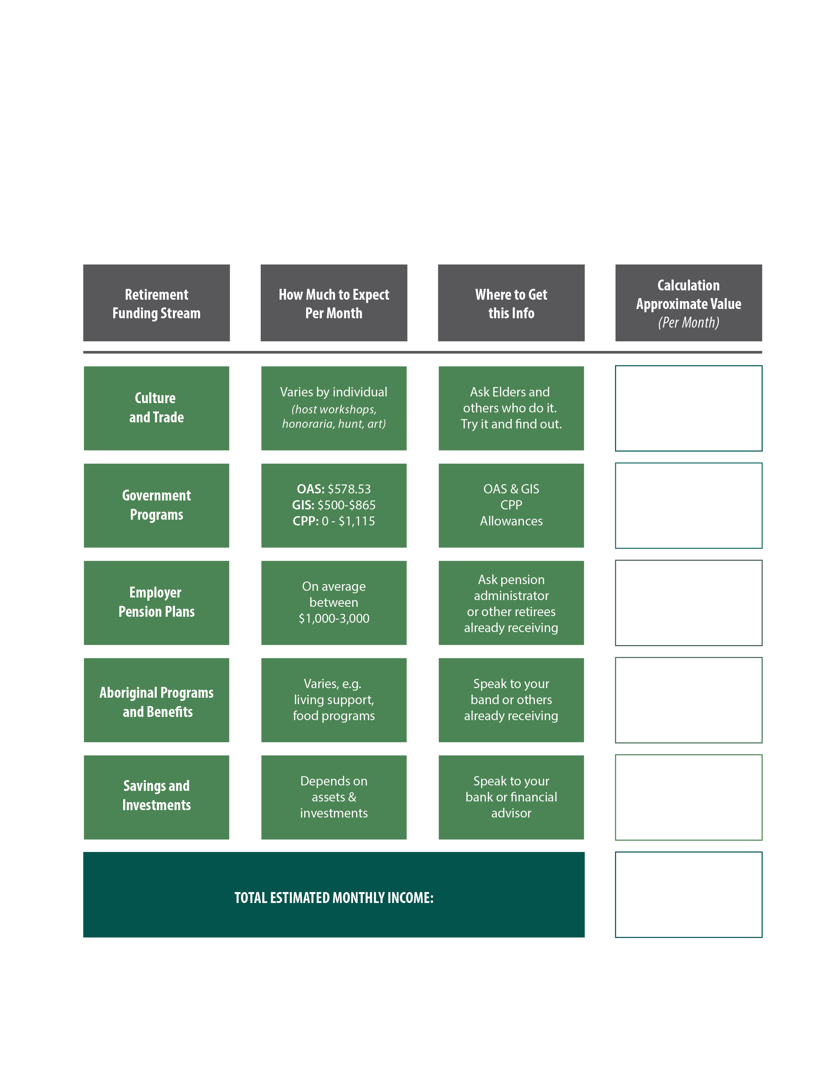
Using this tool based on the “pathways to retirement” visual, calculate your approximate monthly income that will be available to you when you choose to retire or start drawing on your pension. Note that this tool does not include income earned through paid work, which some people choose to continue into their Elder years.
OAS and GIS information: http://www.esdc.gc.ca/en/cpp/oas/payments.page
CPP Retirement Income Calculator: http://www.esdc.gc.ca/en/cpp/cric.page
Allowances for people 60-64: http://www.esdc.gc.ca/en/cpp/oas/allowance/benefit_amount.page

Holistic Retirement Planning – Action Plan Sheet

What is your dream vision for your Elder years?
What will you do? Who will you spend time with? Where will you live? How will you support your community?

Considering what we have discussed today, what 3 goals do you commit to pursuing in order to realize your Vision for your Elder years? Consider goals that reflect different aspects of holistic planning (such as a health, finances, spirit, social, Safety, etc.)

Goal Description  (what will you do/accomplish) | When will I do this by (date) | Who can help me realize this goal (person, organization)
1.

2.

3.

Do you have any other ideas or thoughts about planning for "retirement" or living as an Elder?

Taking the Next Steps – Ideas and Resources
The curriculum workshop is an introduction to the topic of planning holistically for retirement and financial living as an Elder. If you want to learn more about the topic you can visit the Holistic Retirement Planning webpage at http://anpbc.com/toolkits/holistic-retirement-planning/ You can also seek out resources online (see suggestions below) or speak to an Elder/advisor.

If you are looking for information on finances and retirement, consider:
- Speaking to a trusted friend or family member who has financial skills and good money management.
- Approaching the comptroller or finance person in your workplace, who can go over options regarding automatic withdrawals, RRSPs, pension plans, etc.
- Going to see a certified financial planner or expert.
- Viewing the information provide online, such as through Revenue Canada https://www.canada.ca/en/services/benefits/publicpensions.html
- Go through the Aboriginal Financial Officers Association’s (AFOA) First Nations Financial Fitness Guide http://www.afoabc.org/wp-content/uploads/2015/06/financial-literacy-handbook.pdf
- Visit the Aboriginal Financial Literacy Committee’s First Nations Financial Fitness page: http://iflc.info/
- If your organization contributes to a corporate pension plan, speak to someone from your pension
administrator. If your organization is not yet a member of a pension plan, consider joining one and speaking to anpBC Strategy pension advisor Lorna Eastman (lorna@lornaeastmanfinancial.com) or
Eagle Bay Financial Services (http://eaglebay.financial/) representative or someone form the Municipal Pension Plan (https://mpp.pensionsbc.ca/)

Tips:
- Your bank will offer financial advice at no cost, but be mindful they will try to sell you financial products. Credit unions are also very keen to support members and some particularly support Indigenous peoples and projects. Since banks will try to sell you their products, you should also consider approaching a broker who will look for the best deal across several financial product offerings.
- Another option is to get advice from a financial planner who does not sell products. Note that these experts usually charge fees for their time and advice.
- When buying financial products, don’t be afraid to ask what the seller’s commission will be and how much you will be earning. It’s your right to know!

If you are looking for information about improving your health or spirit, consider:
- Asking a trusted Elder or knowledge keeper to provide guidance
- Speaking to your doctor, a fitness trainer or dietician

If you are looking for information regarding support available for Elders:
- Download and view the BC Elder’s guide from the First Nations Health Authority: http://www.fnha.ca/wellnessContent/Wellness/BC_EldersGuide.pdf
- Download and view the BC Seniors guide: http://www2.gov.bc.ca/assets/gov/people/seniors/about-seniorsbc/guide/bc-seniors-guide-11th-edition.pdf
- Look through the BC government website for seniors http://www2.gov.bc.ca/gov/content/family-social-supports/seniors/about-seniorsbc/seniors-related-initiatives/bc-seniors-guide
- Find a local Friendship Centre that has an Elder’s program. There are 24 Native Friendship Centres across BC. You can contact the BC Association of Aboriginal Friendship Centres to learn more about Friendship Centres and find the one nearest you: https://www.bcaafc.com/index.php
- Find a local community centre with a seniors program

